PETER PHILLIPS
Director

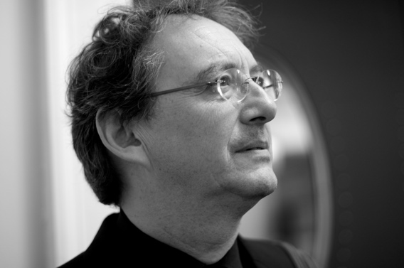
Peter Phillips has dedicated his career to the research and performance of Renaissance polyphony, and to the perfecting of choral sound. He founded The Tallis Scholars in 1973, with whom he has now appeared in over 2,300 concerts and made over 60 discs, world-wide. As a result of this commitment Peter Phillips and The Tallis Scholars have done more than any other group to establish the sacred vocal music of the Renaissance as one of the great repertoires of Western classical music.
Photo © Valérie Batselaere
Peter Phillips also conducts other specialist ensembles. He is currently working with the BBC Singers, the Netherlands Chamber Choir, the Estonian Philharmonic Chamber Choir, Intrada (Moscow) and El Leon de Oro (Spain). He is Patron of the Chapel Choir of Merton College Oxford.
In addition to conducting, Peter Phillips is well-known as a writer. For 33 years he contributed a regular music column to The Spectator. In 1995 he became the publisher of The Musical Times, the oldest continuously published music journal in the world. His first book, English Sacred Music 1549-1649, was published by Gimell in 1991, while his second, What We Really Do, appeared in 2013. During 2018, BBC Radio 3 broadcast his view of Renaissance polyphony, in a series of six hour-long programmes, entitled The Glory of Polyphony.
In 2005 Peter Phillips was made a Chevalier de l'Ordre des Arts et des Lettres by the French Minister of Culture. In 2008 Peter helped to found the chapel choir of Merton College Oxford, where he is a Bodley Fellow; and in 2021 he was elected an Honorary Fellow of St John’s College, Oxford.

www.thetallisscholars.co.uk / www.gimell.com

This biography is valid for use until July 2021. We update our biographies regularly and ask that they are not altered without permission. For updated versions, please e-mail sm@jamesbrownmanagement.com

