THE TALLIS SCHOLARS
Vocal Ensemble

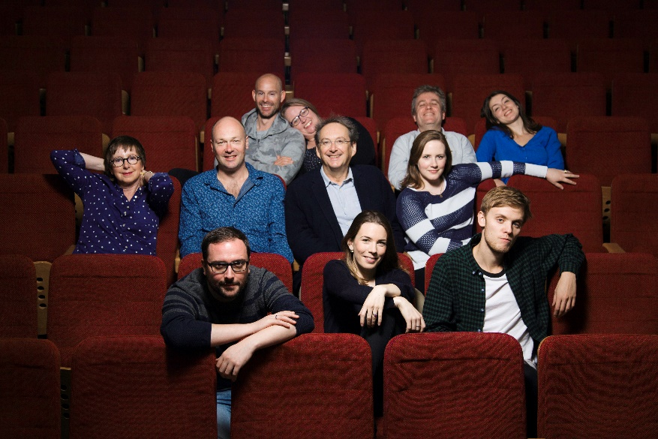
The Tallis Scholars were founded in 1973 by their director, Peter Phillips. Through their recordings and concert performances, they have established themselves as the leading exponents of Renaissance sacred music throughout the world. Peter Phillips has worked with the ensemble to create the purity and clarity of sound which he feels best serves the Renaissance repertoire. It is the resulting beauty of sound for which The Tallis Scholars have become so widely renowned.
Photo © Nick Rutter
Photo: Nick Rutter

The Tallis Scholars perform in both sacred and secular venues, giving around 80 concerts each year. In 2013 the group celebrated their 40th anniversary with a World Tour, and now look ahead to their 50th anniversary in 2023. As of the beginning of the cancellations caused by the COVID-19 crisis, the Tallis Scholars had made 2,327 appearances, worldwide.

2020/21 season highlights include performances in: Amsterdam, Oslo, Zurich and Dortmund Festivals, and tours of Italy. In 2021, the group celebrates Josquin des Prez’ 500th anniversary with performances of all eighteen of the composer’s masses, culminating in a complete performance in the Boulez Saal, Berlin over the course of four days in August.

Recordings by The Tallis Scholars have attracted many awards throughout the world. The latest recording of Josquin and Bauldeweyn masses was released in November 2019. This is the 8th of 9 albums in The Tallis Scholars' project to record and release all Josquin's masses before the composer’s 500th anniversary in 2021.

www.thetallisscholars.co.uk / www.gimell.com

This biography is valid for use until July 2021. We update our biographies regularly and ask that they are not altered without permission. For updated versions, please email sarah.h.mansfield@outlook.com

