THE TALLIS SCHOLARS
Vocal Ensemble

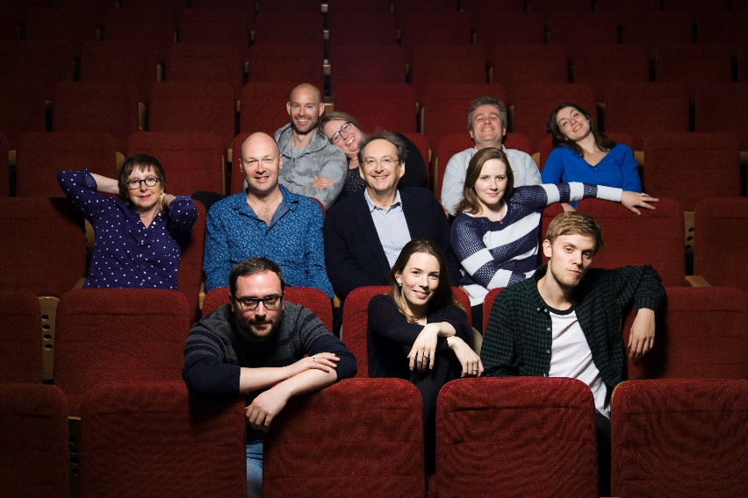
The Tallis Scholars were founded in 1973 by their director, Peter Phillips. Through their recordings and concert performances, they have established themselves as the leading exponents of Renaissance sacred music throughout the world. Peter Phillips has worked with the ensemble to create, through good tuning and blend, the purity and clarity of sound which he feels best serves the Renaissance repertoire, allowing every detail of the musical lines to be heard. It is the resulting beauty of sound for which The Tallis Scholars have become so widely renowned.
Photo © Nick Rutter

The Tallis Scholars perform in both sacred and secular venues, giving around 80 concerts each year. In 2013 the group celebrated their 40th anniversary with a World Tour, performing 99 events in 80 venues in 16 countries. They now look ahead to their 50th anniversary in 2023. In 2020 Gimell Records celebrated 40 years of recording the group by releasing a remastered version of the 1980 recording of Allergri’s ‘Miserere’. As of the beginning of the cancellations caused by the COVID-19 crisis, the Tallis Scholars had made 2,327 appearances, worldwide.

2021/22 season highlights include performances in Amsterdam, Vienna, Dortmund, Bremen, two tours of Italy, a number of appearances in London as well as their usual touring schedule around the USA, Europe and the UK. As part of Josquin des Prez’ postponed 500th anniversary celebrations The Tallis Scholars sing all eighteen of the composer’s masses over the course of 4 days at the Boulez Saal in Berlin in July 2022.

Recordings by The Tallis Scholars have attracted many awards throughout the world. In 1987 their recording of Josquin's Missa La sol fa re mi and Missa Pange lingua received Gramophone magazine’s Record of the Year award, the first recording of early music ever to win this coveted award. In 1989 the French magazine Diapason gave two of its Diapason d'Or de l'Année awards for the recordings of a mass and motets by Lassus and for Josquin's two masses based on the chanson L'Homme armé. Their recording of Palestrina's Missa Assumpta est Maria and Missa Sicut lilium was awarded Gramophone's Early Music Award in 1991; they received the 1994 Early Music Award for their recording of music by Cipriano de Rore; and the same distinction again in 2005 for their disc of music by John Browne. The Tallis Scholars were nominated for a Grammy Award in 2001, 2009 and 2010. In November 2012 their recording of Josquin's Missa De beata virgine and Missa Ave maris stella received a Diapason d’Or de l’Année and in their 40th anniversary year they were welcomed into the Gramophone ‘Hall of Fame’ by public vote. In a departure for the group in Spring 2015 The Tallis Scholars released a disc of music by Arvo Pärt called Tintinnabuli which received great praise across the board. The latest recording of Josquin masses including Missa Hercules Dux Ferrarie was released in November 2020 and was winner of the BBC Music Magazine’s much coveted Recording of the Year Award in 2021. This disc was the last of nine albums in The Tallis Scholars' project to record and release all Josquin's masses before the 500th anniversary of the composer’s death in 2021.

www.thetallisscholars.co.uk / www.gimell.com

This biography is valid for use until Dec 2021. We update our biographies regularly and ask that they are not altered without permission. For updated versions, please email Sarah Mansfield: sm@jamesbrownmanagement.com

